

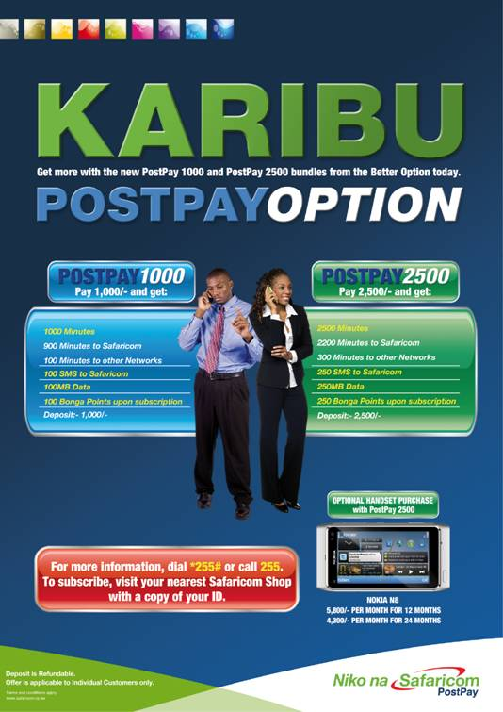

Q) How much do I need to pay to get the bundle?
For PostPay 1000:
The customer will pay Kshs 2,000. That is;
  - Kshs 1,000 – Deposit
  - Kshs 1,000 – bundle payment
For PostPay 2500:
The customer will pay Kshs 5,000. That is;
  - Kshs 2,500 – Deposit
  - Kshs 2,500 – bundle payment

The Postpay 2500 bundle also has an option of signing up for a Nokia N8 phone payable in either 12 or 24 months installments.

Q) What is the monthly repayment if I sign up for the Nokia N8 phone option?

The monthly payment is broken down as follows:

- 12 months – Kshs 5,800 that covers:
  - Kshs 3,300/- Monthly payment for the handset
  - Kshs 2,500/- Monthly payment for the bundle

- 24 months – Kshs 4,300 that covers:
  - Kshs 1,800/- Monthly payment for the handset
  - Kshs 2,500/- Monthly payment for the bundle

To sign up, kindly visit any of the Safaricom Retail Shops.

For more information, kindly dial *255# or call 255. The call is free. You can also visit our website on www.safaricom.co.ke

